# Assignment 2

### matriculation number: 200009834

## Task 1: Translation

First analyze the customer. Since the customer has multiple phone numbers, another table needs to be created. The conversion is as follows:

Customer(customer_id, name, email, street, city, postcode, country)

Entity set: Customer

Primary key: customer_id

Multivalued attributes: phone

Composite attribute: address

General attribute: name

Customer_phone(customer_id, phone_type, phone_number)

Entity set: Customer_phone

Primary key: customer_id

Foreign key: customer_id

General attribute: phone_type, phone_number

Next, look at the order table on the left side of the ER diagram. The order needs to establish a relationship with the customer through Places, so my conversion is as follows:

Order(order_id, delivery_street, delivery_city, delivery_postcode, delivery_country, date_ordered, date_delivered)

Entity set: Order

Primary key: order_id

Composite attribute: delivery_address

General attribute: date_ordered, date_delivered

Order_Places(order_id, customer_id)

Entity set: Order_Places

Primary keys: order_id, customer_id

Foreign keys: order_id, customer_id

Immediately afterwards, continue to observe the right side of the ER diagram with the customer as the center. It is the book table. There are genre in which another table needs to be created because it is a multi-valued attribute. The details are as follows:

Book(book_id, title, author, publisher)

Entity set: Book

Primary key: book_id

Multivalued attributes: genre

General attribute: title, author, publisher

Book_genre(book_id, genre)

Entity set: Book_genre

Primary key: book_id

Foreign key: book_id

General key: genre

Then, the relationship between the customer and the book is reviews, so the constructed relationship is as follows:

Reviews(book_id, customer_id, rating)

Entity set: Reviews

Primary keys: book_id, customer_id

Foreign keys: book_id, customer_id

General attribute: rating

Next, observe the lower right part of the ER diagram, the first is the Edition, because, Edition is total participation of book. The relationship of construction is as follows:

Edition(book_id, edition, type, price, quantity_in_stock)

Entity set: Edition

Primary keys: book_id, edition, type

Foreign keys: book_id, edition

General attribute: price, quantity_in_stock

Contains(book_id, order_id, edition, type)

Entity set: Contains

Primary keys: book_id, order_id

Foreign keys: book_id, order_id

General attributes: edition, type

The last part is the supplier part, the relationship is as follows:

Supplier(supplier_id, name, account_no)

Entity set: Supplier

Primary key: supplier_id

Multivalued attributes: phone

General attributes: name, account_no

Supplier_phone(supplier_id, phone_number)

Entity set: Supplier

Primary key: supplier_id, phone_number

Foreign key: supplier_id

Supplies(supplier_id, book_id, supply_price)

Entity set: Supplies

Primary keys: supplier_id, book_id

Foreign keys: supplier_id, book_id

General attribute: supply_price

## Task 2: SQL Data Definition

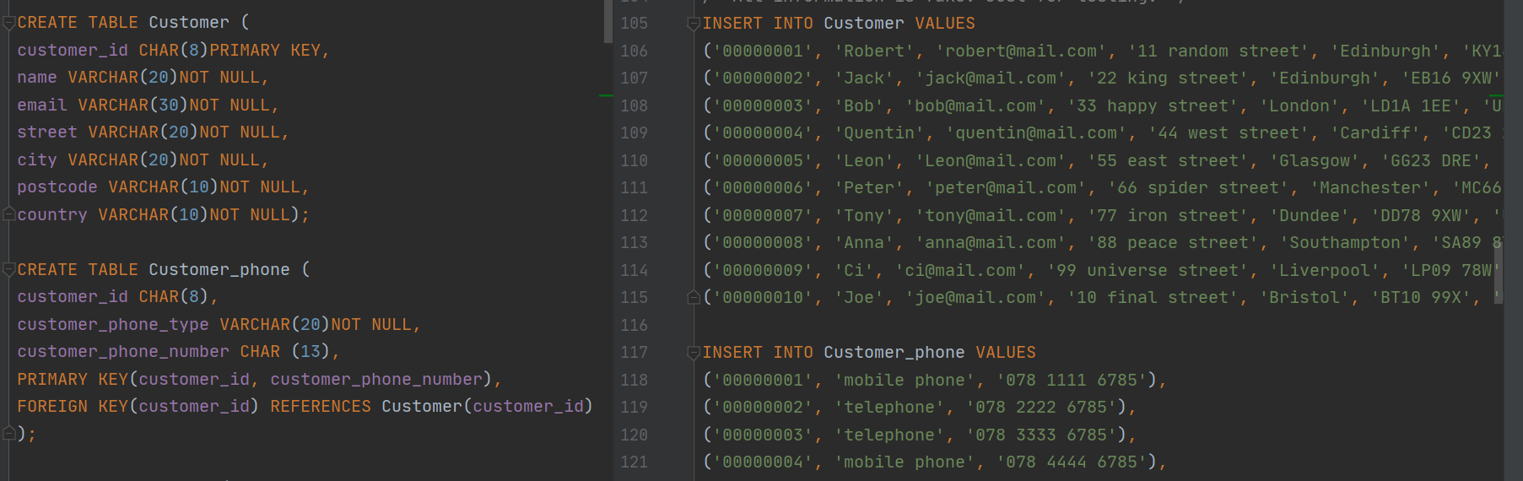

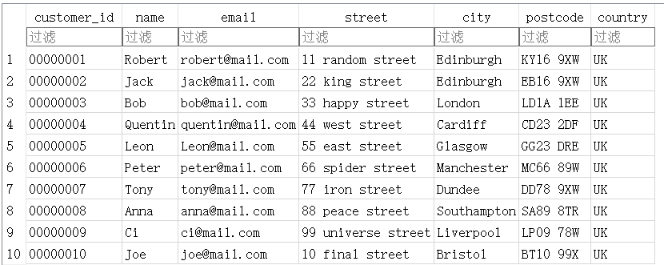

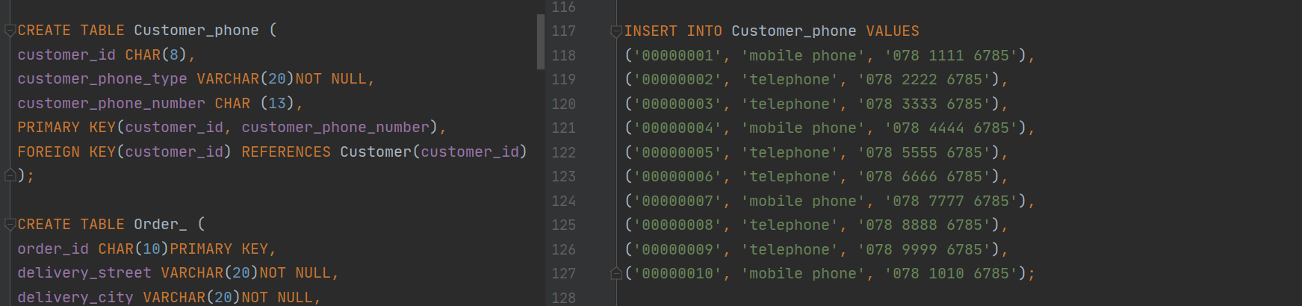

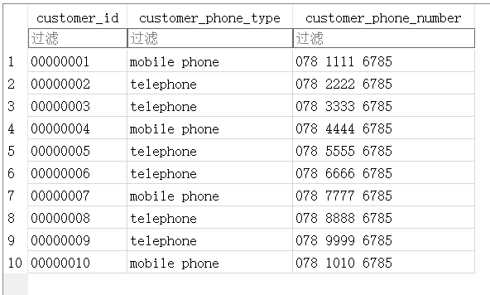

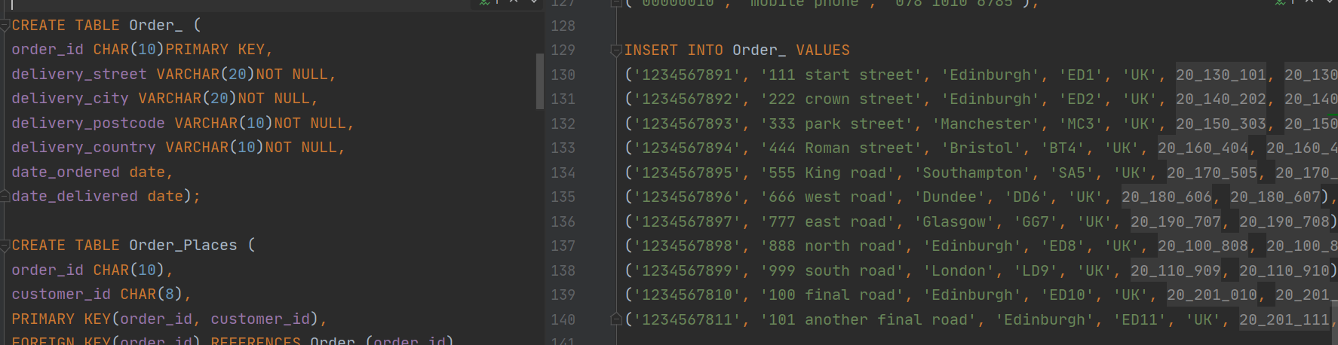

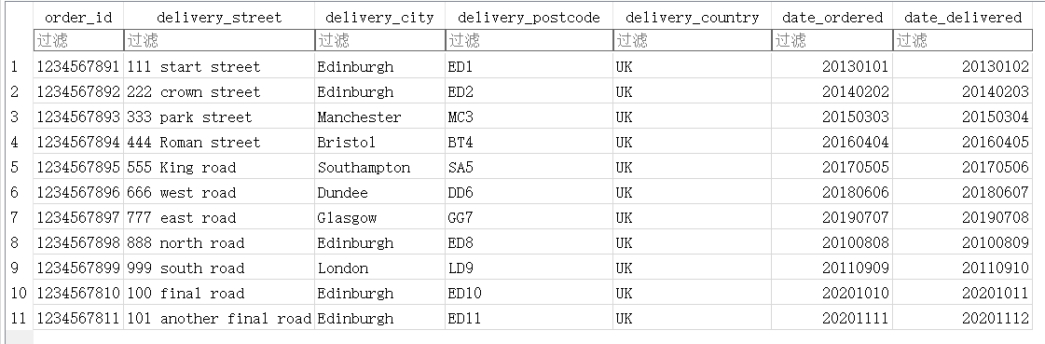

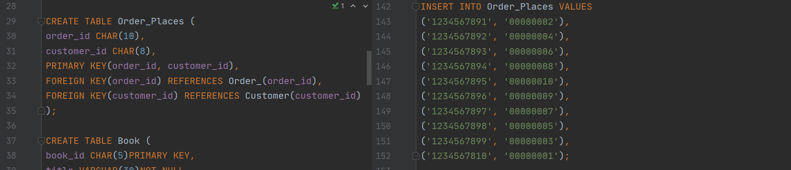

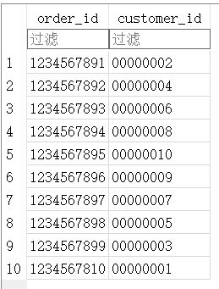

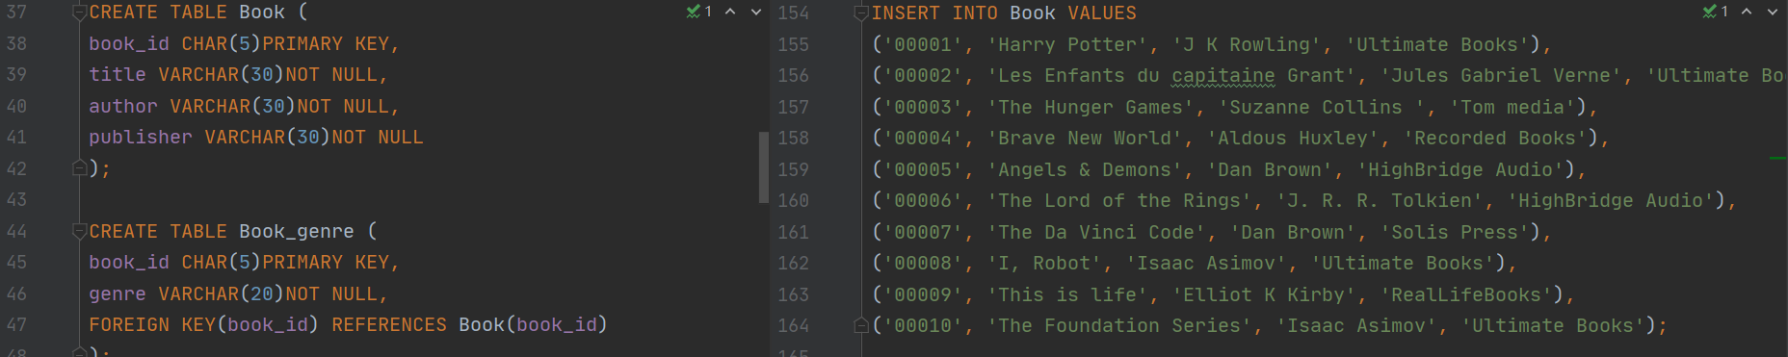

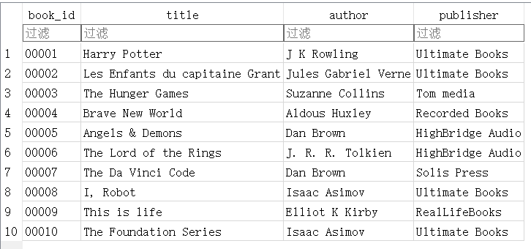

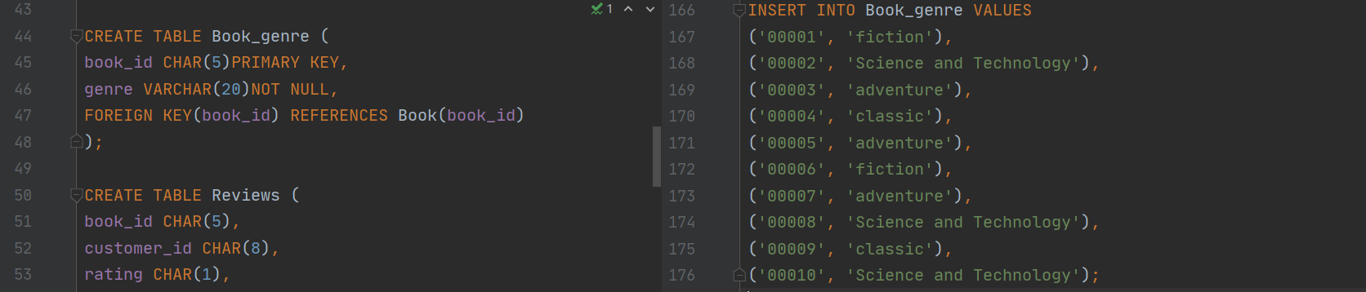

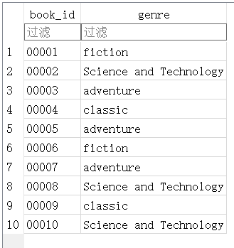

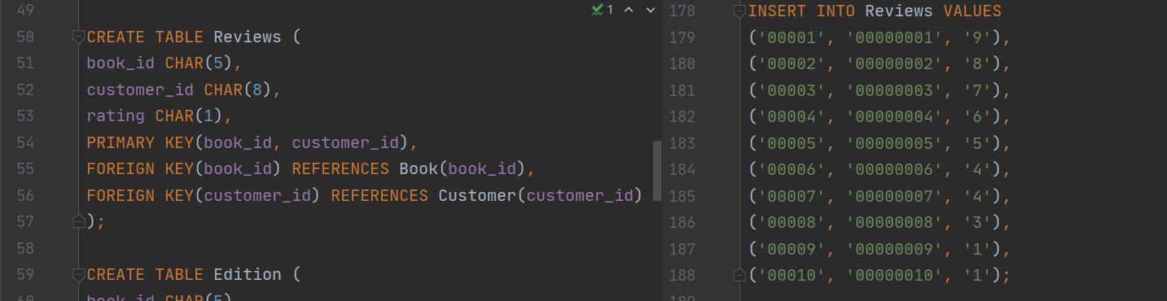

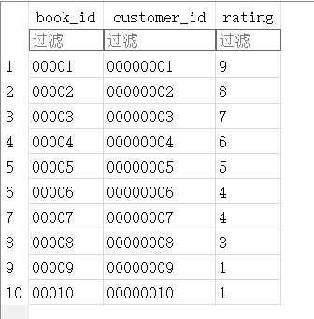

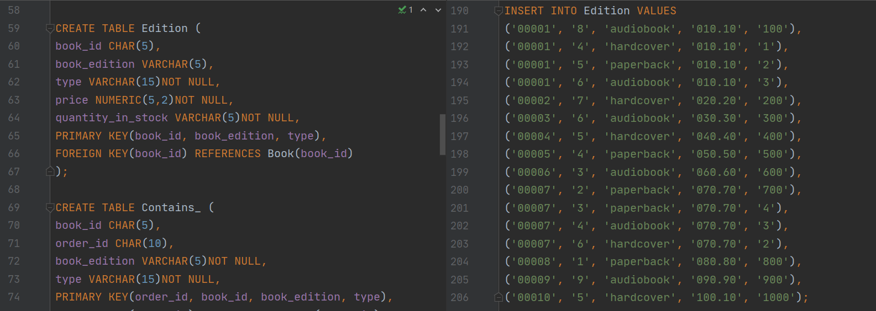

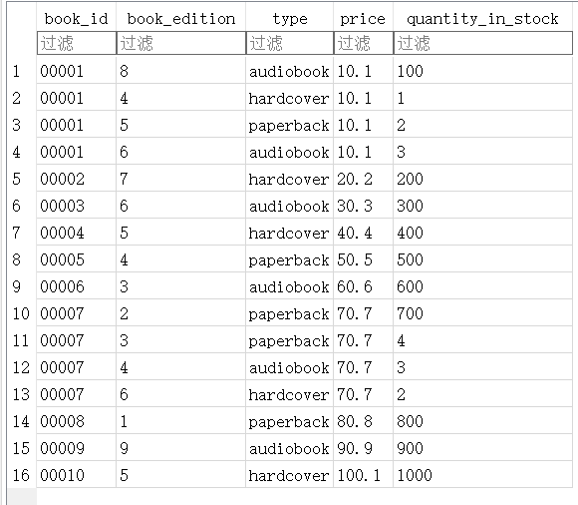

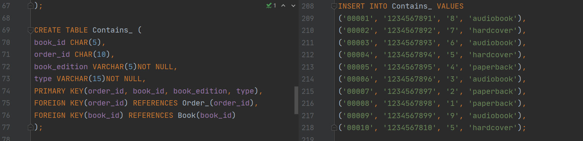

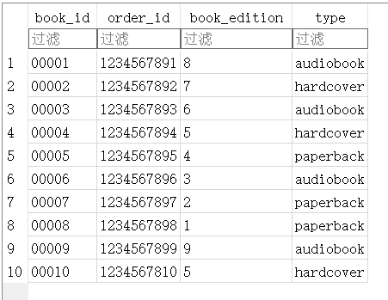

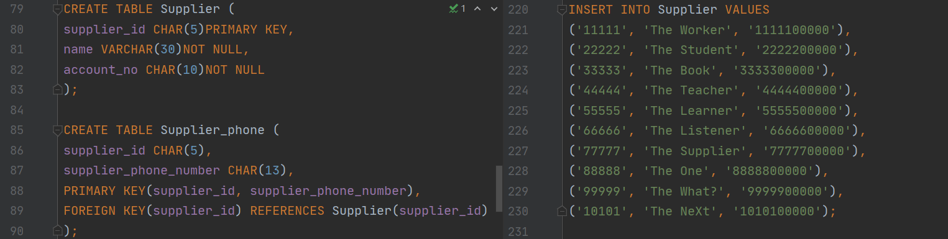

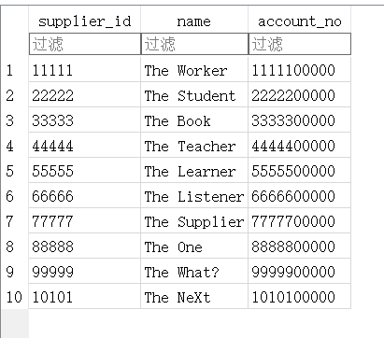

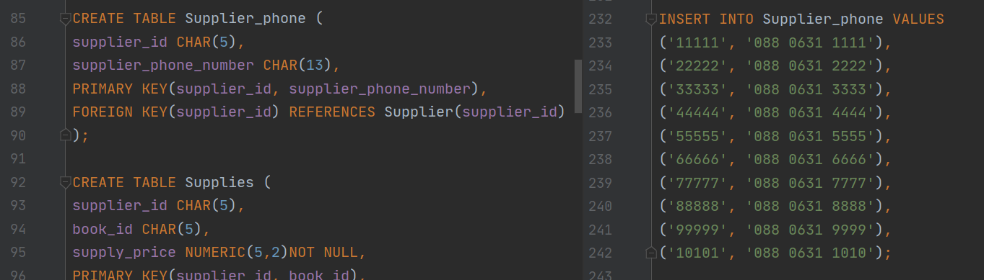

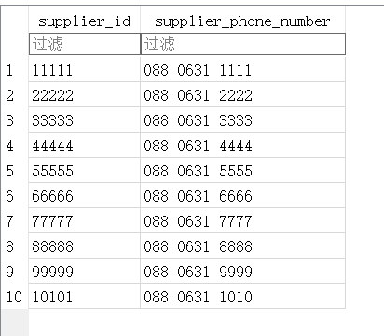

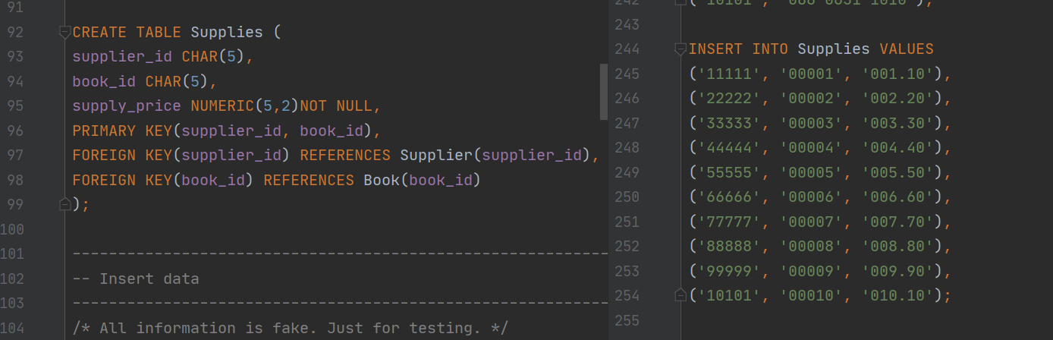

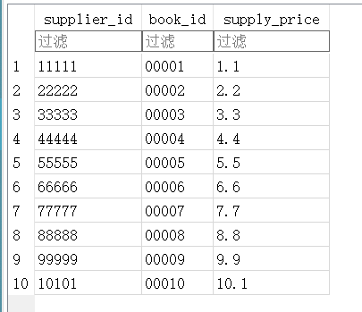

## Task3:

List all books published by “Ultimate Books” which are in the “Science and Technology” genre;

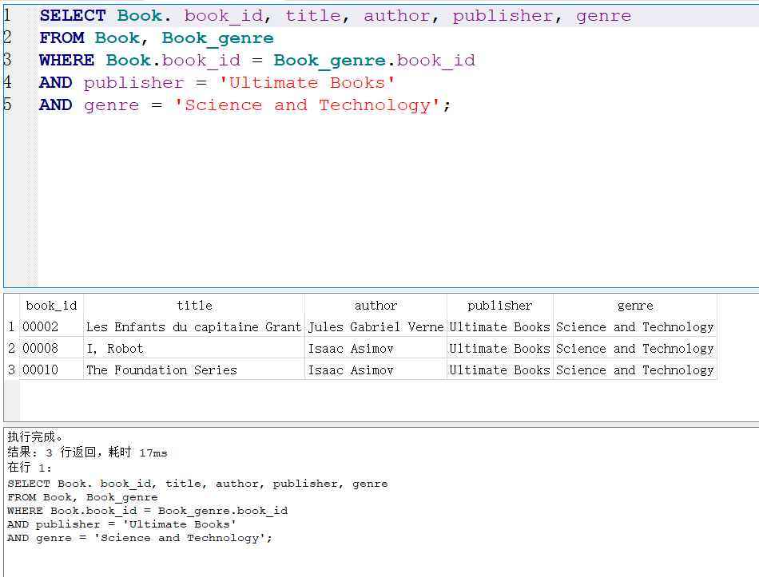

List all orders placed by customers with addresses in the city of Edinburgh, since 2016, in order of date, latest first;

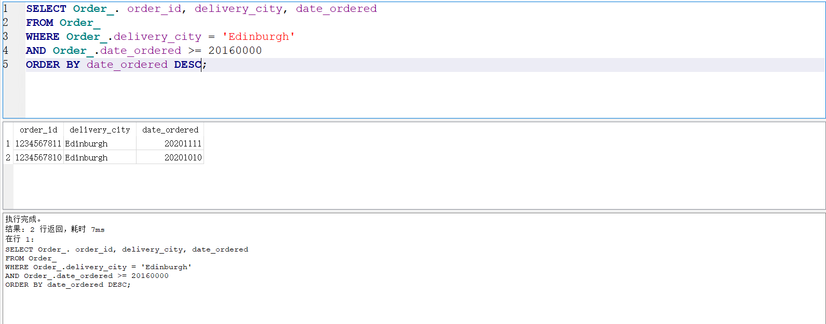

List all book editions which have less than 5 items in stock, together with the name, account number and supply price of the minimum priced supplier for that edition.

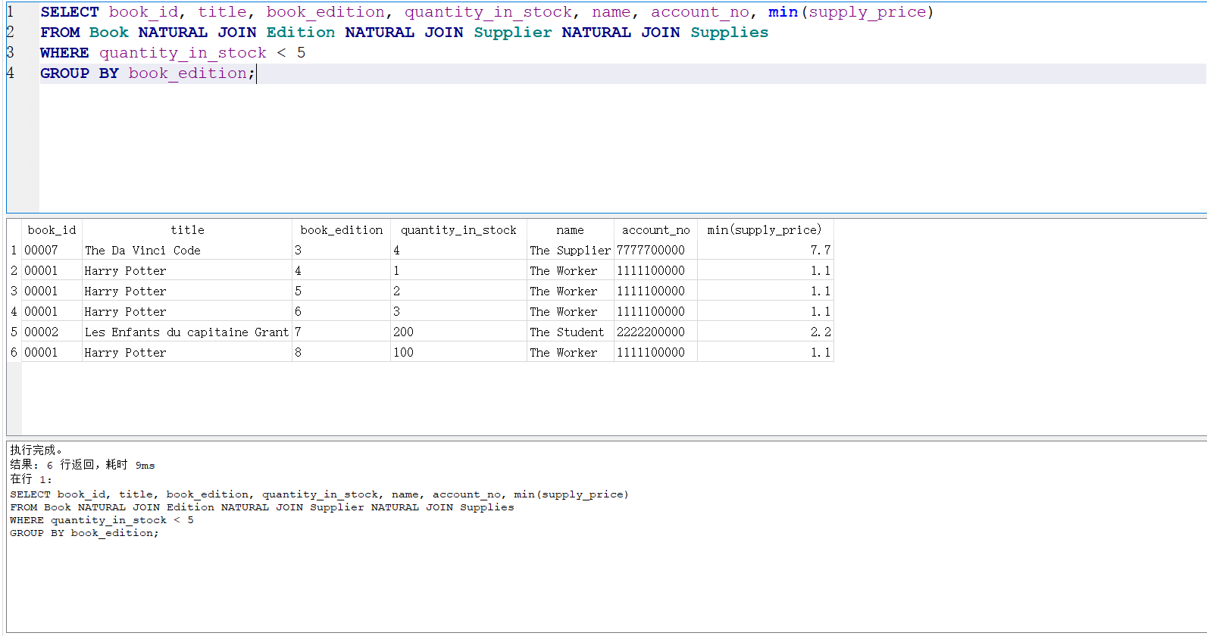

List all books published more than 5th edition, together with the book’s name, author and publisher.

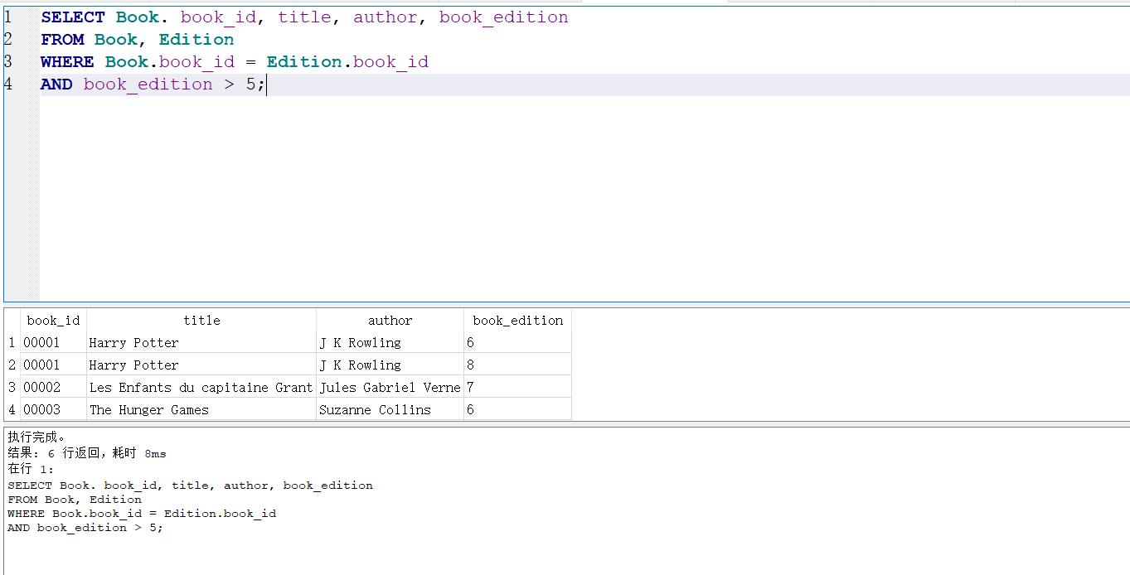

List all books have at least 6 grade rating, recording the book’s title, id and genre.

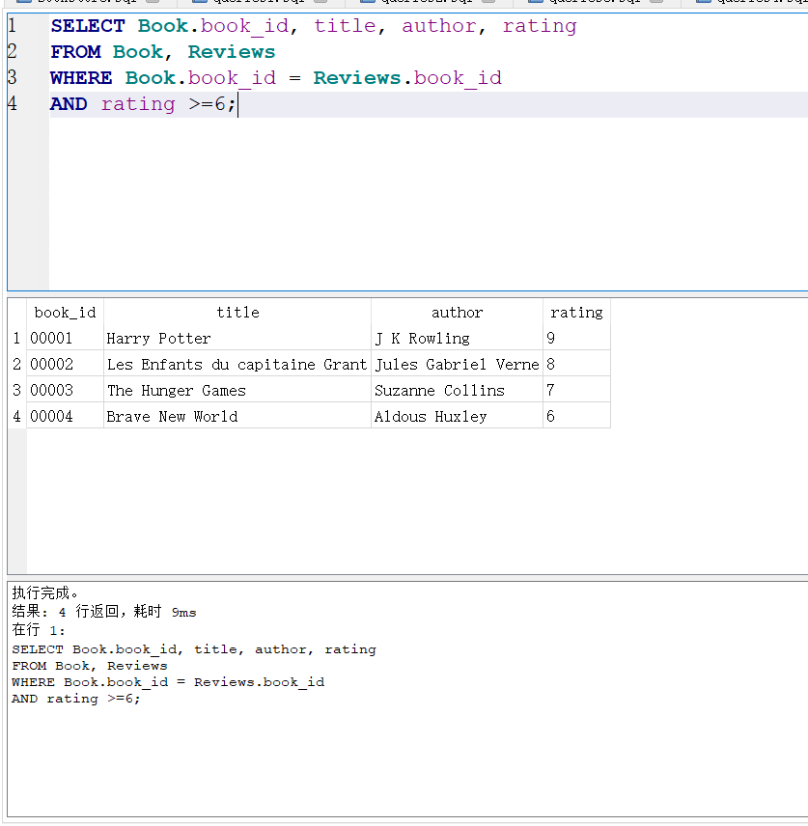

List the customers who ordered after 2016, together with the book’s title and the customers name and email.

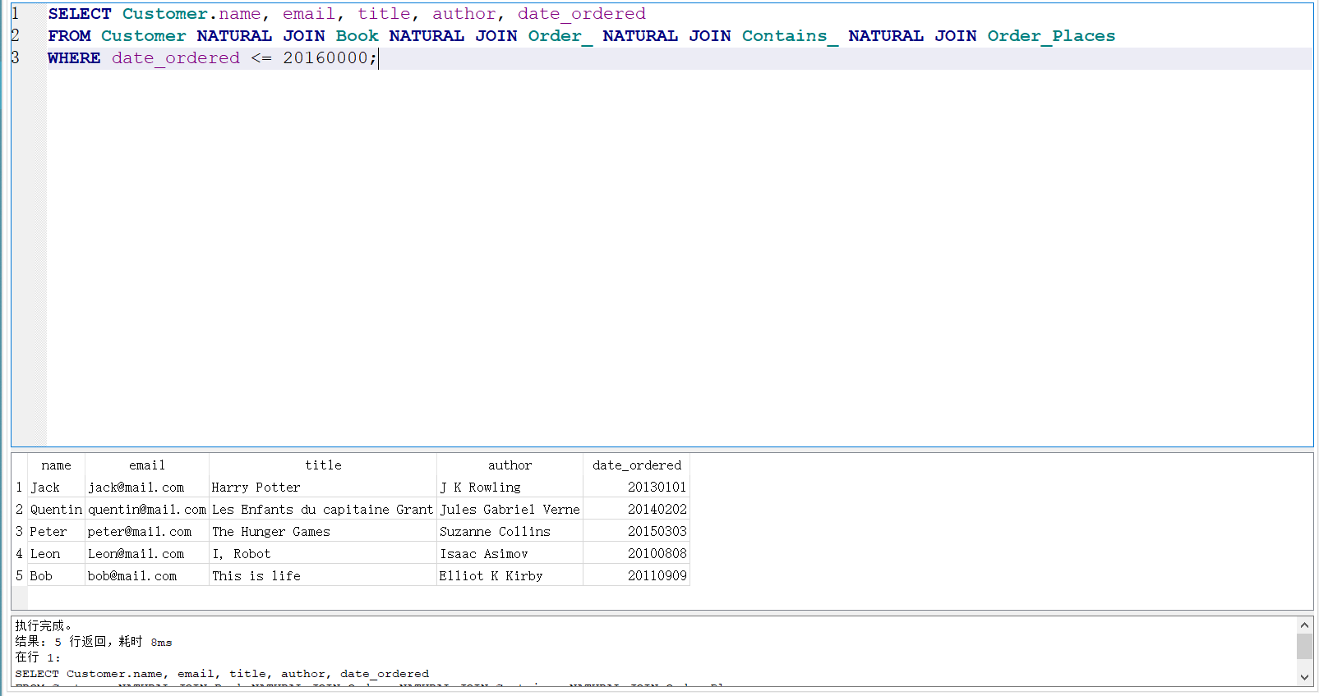

A customer wants to find basic information about all Science and Technology books.

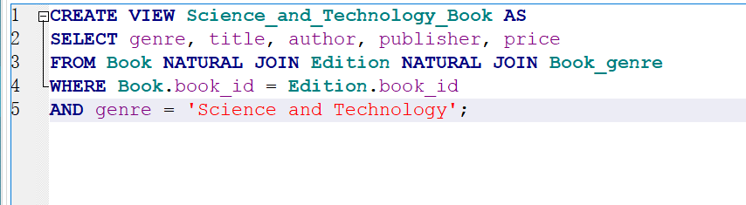

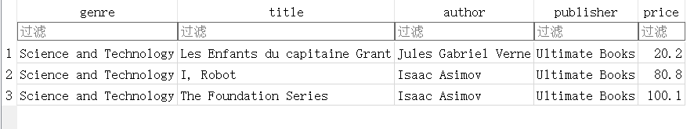

Bookstore employees hope to find all books with less than 100 books in stock.

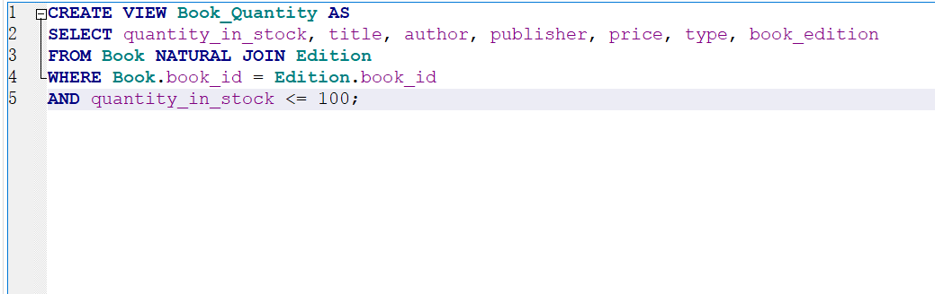

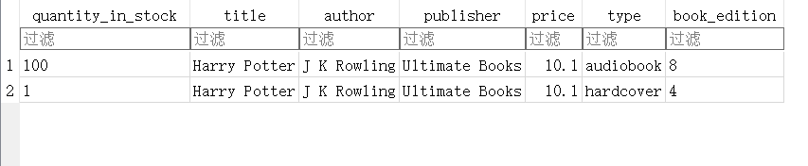

## Task4:

In general, if you can take the class seriously and read more related books provided by the teacher before the next class, then it is not difficult to complete this task. The difficulty for me is the choice of data. When I make a table, I usually encounter various small errors, such as semantics, spelling, etc., which will reduce efficiency and often forget attributes when building tables and queries and name. In addition, when the corresponding SQL query was produced, a lot of repetitions were made because natural connections were not used. And the view part is still not perfect, and there are loopholes in many places. Through this project, I understand that there are many problems in building the database together. Contacting the first project together, I feel that I have grown a lot.